DBMS lab-7

**Prepare using SQL Builtin Functions and write a program that works with PL/SQL Functions**

**PLSQL Procedures**

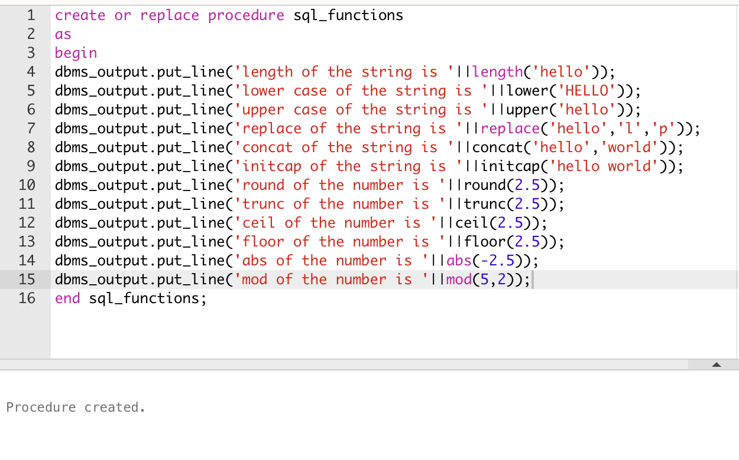

**Execute the procedure**

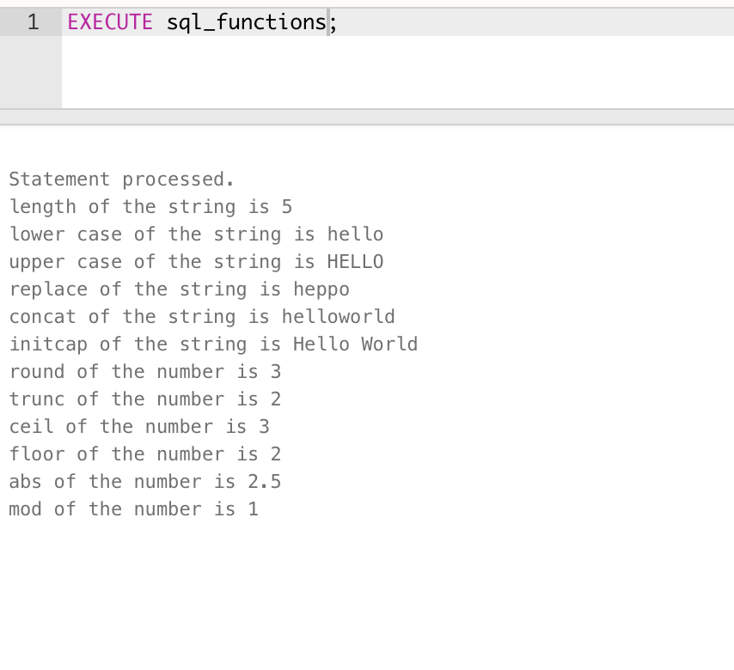

**PLSQL Function**

create or replace function max_department

return number

as

begin

return (select max(id) from department);

end;

**Execute Function**

